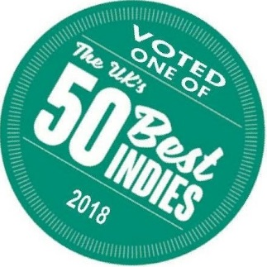
LOCAL WI NE
MERCHANT VOT ED
I N THE TO P50 I N UK
LET'S RAISE A GLASS TO THE AWAR D WI NNING I NDEPENDENT WI NE MER CHANT - THE NAKED GRAPE

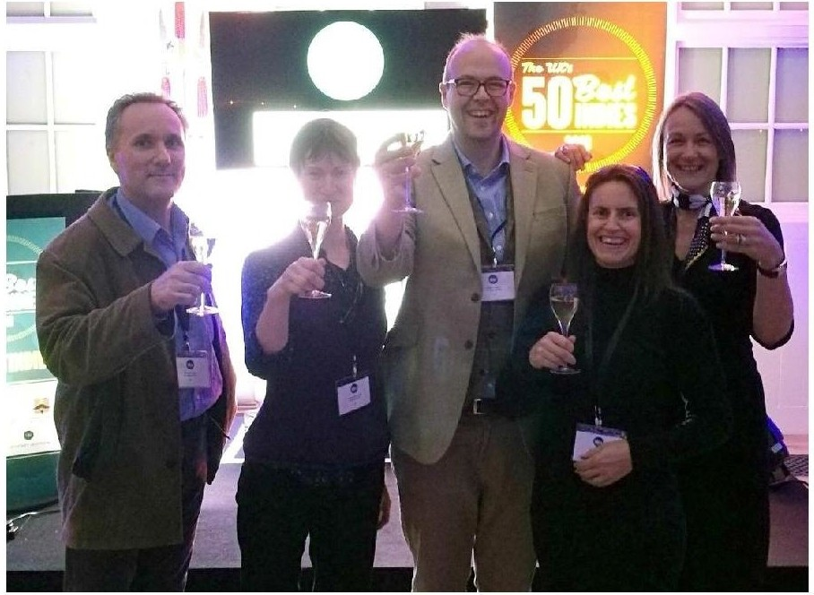

O n M ond ay 24th Septe m ber, t he ded i cated tea m f ro m The N a ked G ra pe t ravelled to t he C i ty of
Lo nd on to attend H a rpe rs [Wine a nd Spirits M a ga zi ne] '50 Best I nd i es' Awa rd s.
These annual awards recognise the very best independent wine merchants in the UK; wine merchants that have excelled in driving forward quality and innovation, providing a benchmark for the trade. With three shops located in Alresford, Four Marks and Hungerford, the Naked Grape live by the philosophy that
life is too short to drink bad wine - which also happens to be the company's motto!

The Naked Grape's Hungerford shop was the only independent wine merchant from Berkshire to make it into the '50 Best Indies' list. The two Hampshire shops in Alresford and Four Marks
faired almost as well by being only one of two independent wine merchants in Hampshire to make it onto the list!

Jo from Stellar Words caught up with Simon Evans, Founder and Managing Director of The Naked Grape to ask him his thoughts on the award.

What does this award mean to The Naked Grape?
Simon Evans: To be named as one of the best independent wine merchants in the UK is an amazing achievement and one we're

very proud of. It's a team effort and I'm immensely proud of my staff. We are a small and very hard working group, with many of the team having been with me for years.
Who are Harpers?
Simon Evans: Harpers is the leading industry magazine and arbiter of' all that is good' in the wine and spirits trade, so receiving recognition from them is a great honour.
Did you know about the awards prior to this achievement? Simon Evans: I found out that this is only the 3rd year the Harpers awards have been presented, and we didn't know anything about our nomination until a letter arrived on my desk.
The criteria for judging is a closely guarded secret and we had no idea anyone was judging us.
Who is the competition you were judged against?
Simon Evans: This is a list of the Top5O, and quite a few businesses listed are much larger and longer established than us. I
think we stand out as we are a traditional wine merchant. We have a clear message of concentrating on the quality and value of our product, everything comes with our personal recommendation.
Quite a few dilute their message with other products; gift cards, wine glasses, and sometimes confectionary. We just concentrate on stocking a superb product and service to back it up.
How have you celebrated?
Simon Evans: Well, we may have mentioned it a couple of times to our customers!. We have a freshly designed van, a huge banner on the shop front at Hungerford, and several other ideas, so yes people may well notice. And as for the Team, I took them all
out for dinner and a celebratory glass or two after the awards ceremony at the Honourable Artillery Company HQ
in London.

Where from here?
We are dedicated to selling the best quality products we can find, and with a strong belief in providing exceptional customer
service, the future for the Naked Grape certainly looks rosey - or should that be Rose!

ALRESFORD I FOUR MARKS I HUNGEFORD
www.thenakedgrape .co.uk

